MESA REDONDA: LA MIRADA CREATIVA

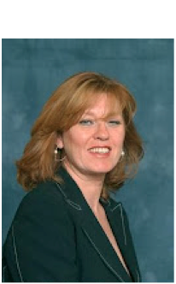

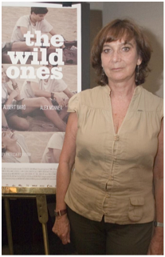
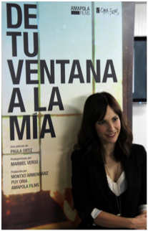
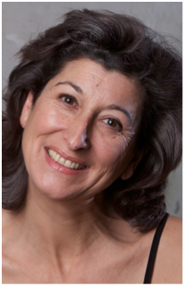
Paula Ortiz
Filmmaker, Producer
Patricia Ferreira
Filmmaker
Araceli Bruch Pla
Actor, Producer,
Writer

Montserrat Alcoverro
TV, Film and Theatre
Actor

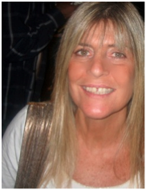

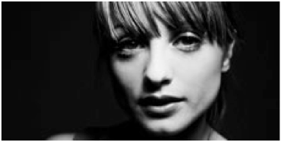
Noemi Weis
Documentarist,
Director, Producer

Lola Blasco Mena
Actor, Playwright, Researcher

